ABOUT
- Cost of membership is 1850 (given as 1810 in website)
- 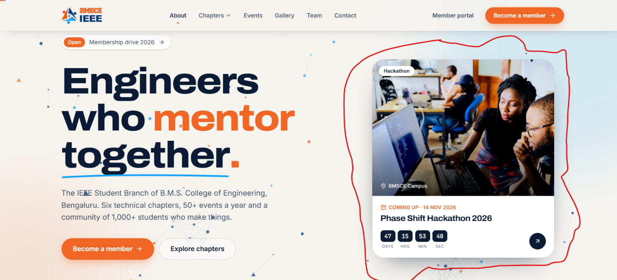
- Images here should be changed and time must be changes accordingly.
- 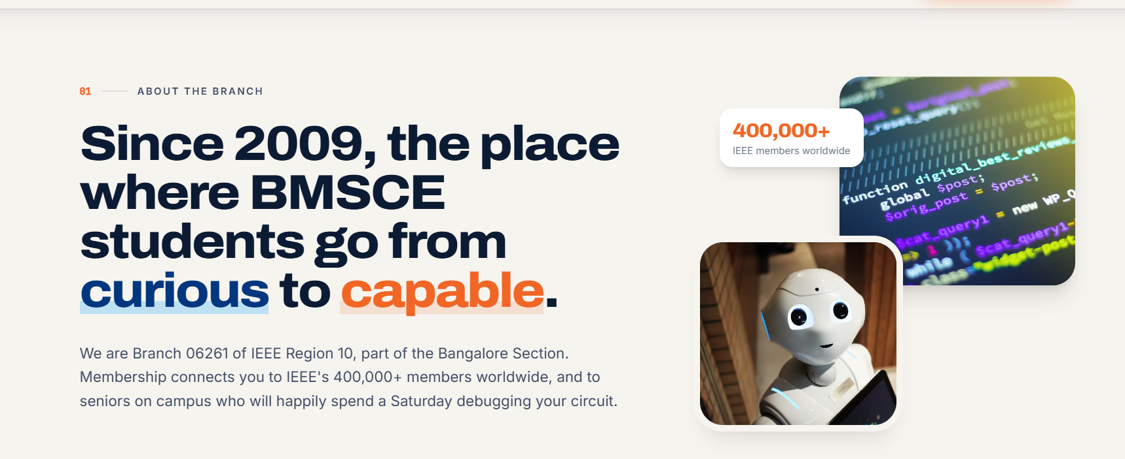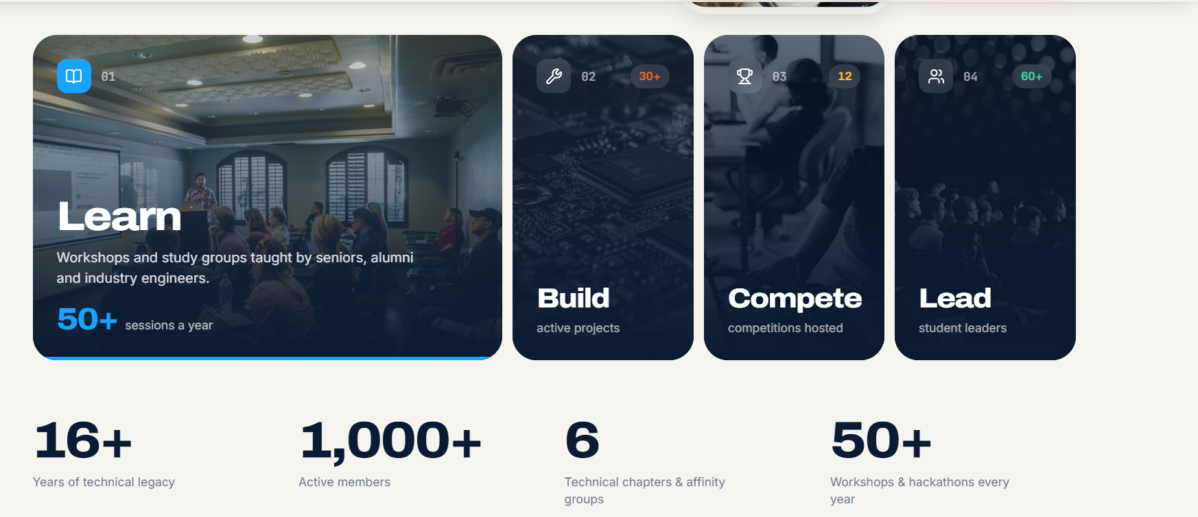
- Images must be changes here also,and number of chapters should be updated in the second image.The number for the 4 cards should also be change ig. And i dont think we should include the part in first image which say “to seniors on the campus who will happily spend a saturday debugging your circuit”
- 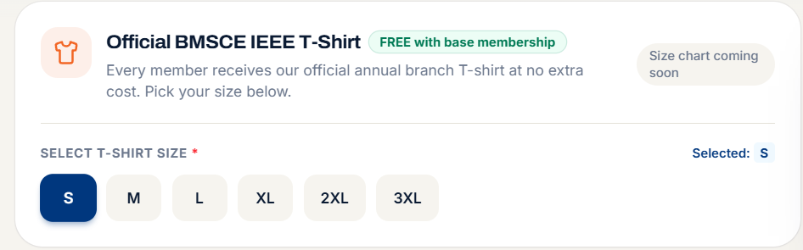
- Size chart not given yet
- 
- Actual people’s linkedin is given here and pics should also be changed
- 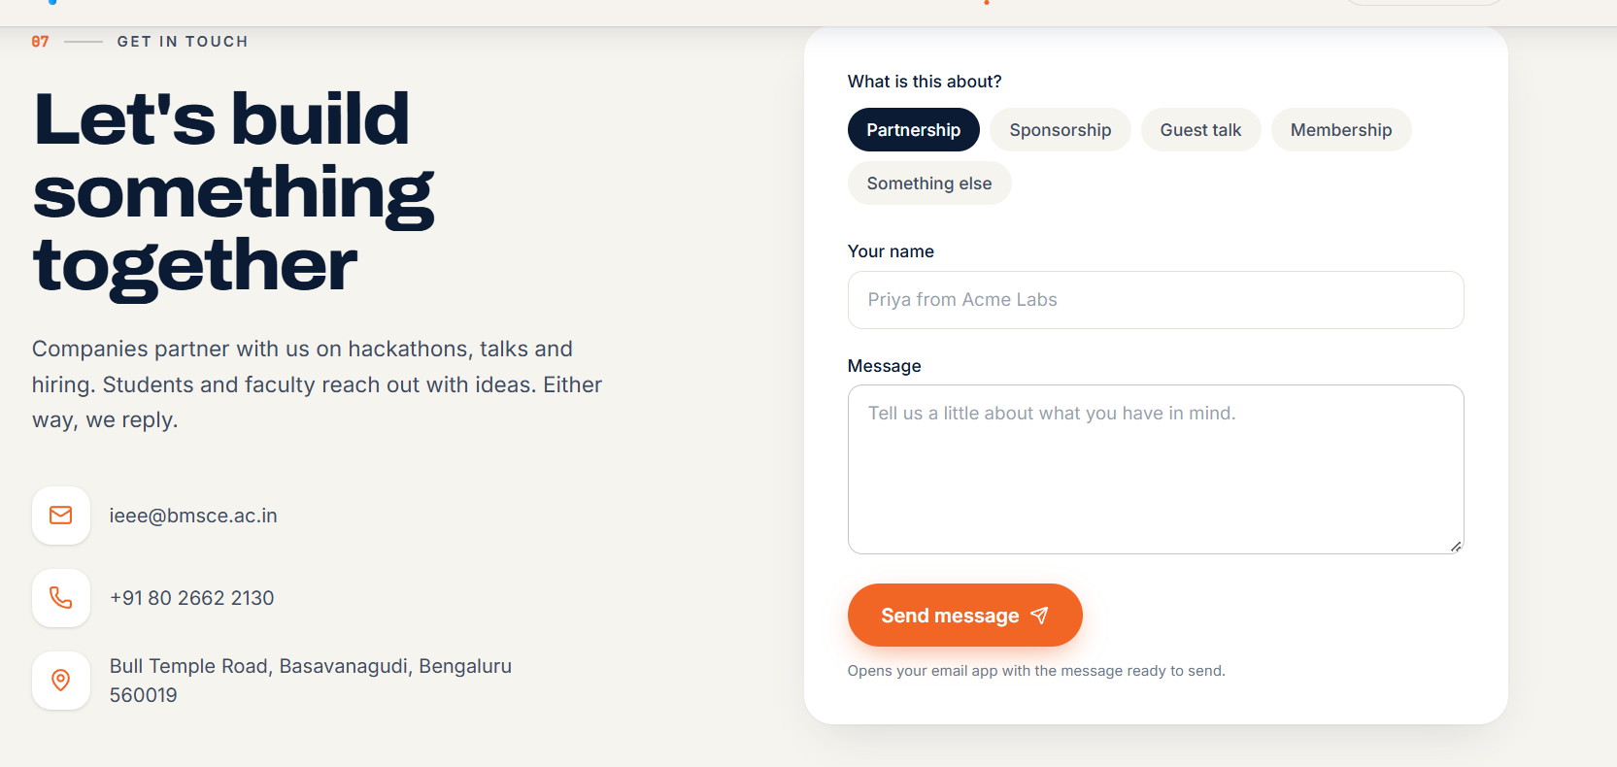
- I think its better if we remove the”priya from acme labs” and change it to something else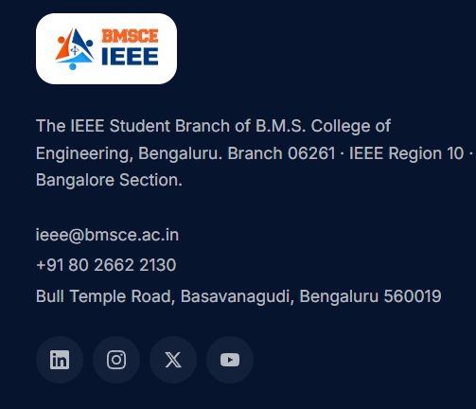
- Not sure if we have an x handle for bmsce ieee,but when clicked here it leads to an error

CHAPTERS
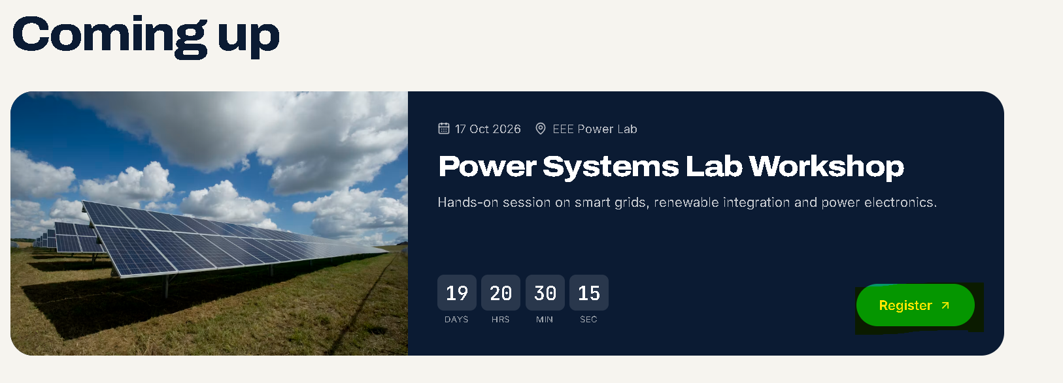
Should these buttons take is somewhere because rn they take u back to the chapters info
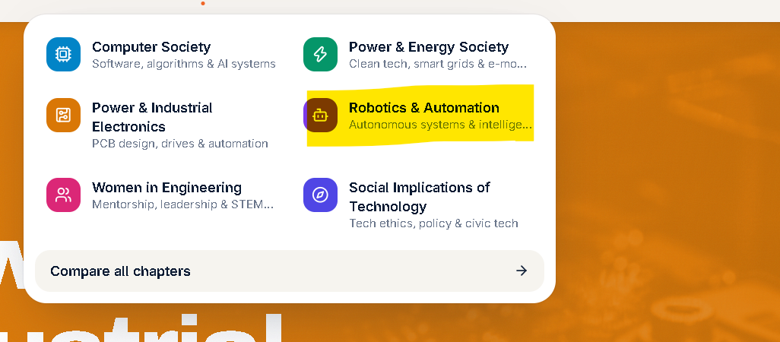
To be removed

Also i feel content is very less or it just feels so generic


To be removed

EVENTS
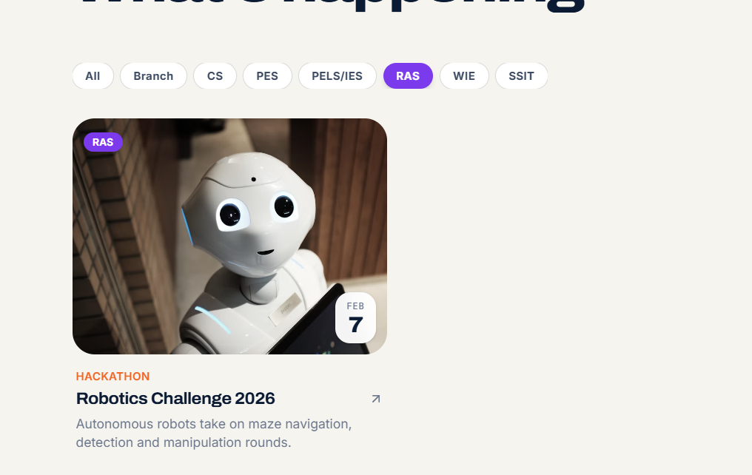this should not be there

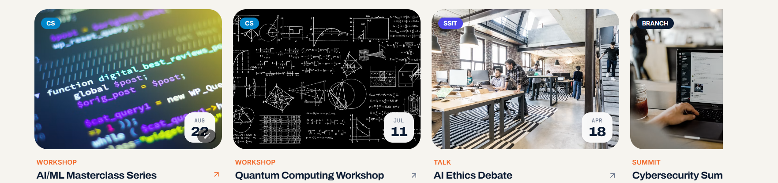
Need to have real data and images here

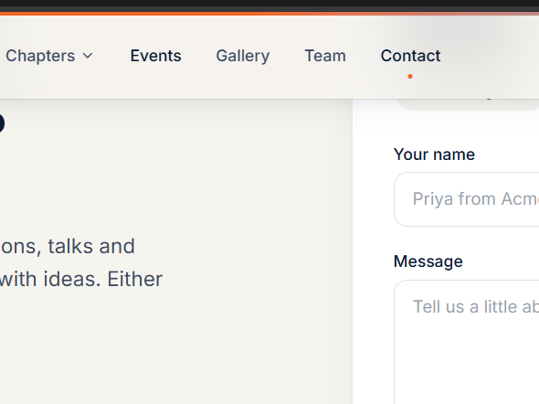
Sometimes these buttons wont work

Selecting any event is redirecting to the about page

Clicking a past event can lead to event details like a short description,photos speaker if any..

GALLERY

-may be the size of the viewable photos can be reduced it looks un even 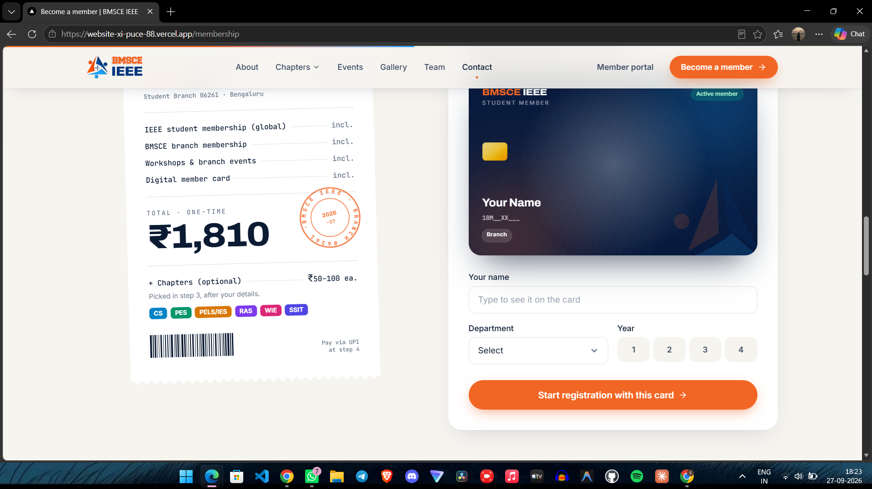
more payment methods, for now only upi is there we can add internet banking and cards option

MEMBER PART
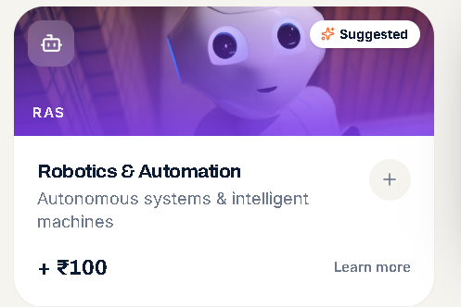
THIS has to be removed
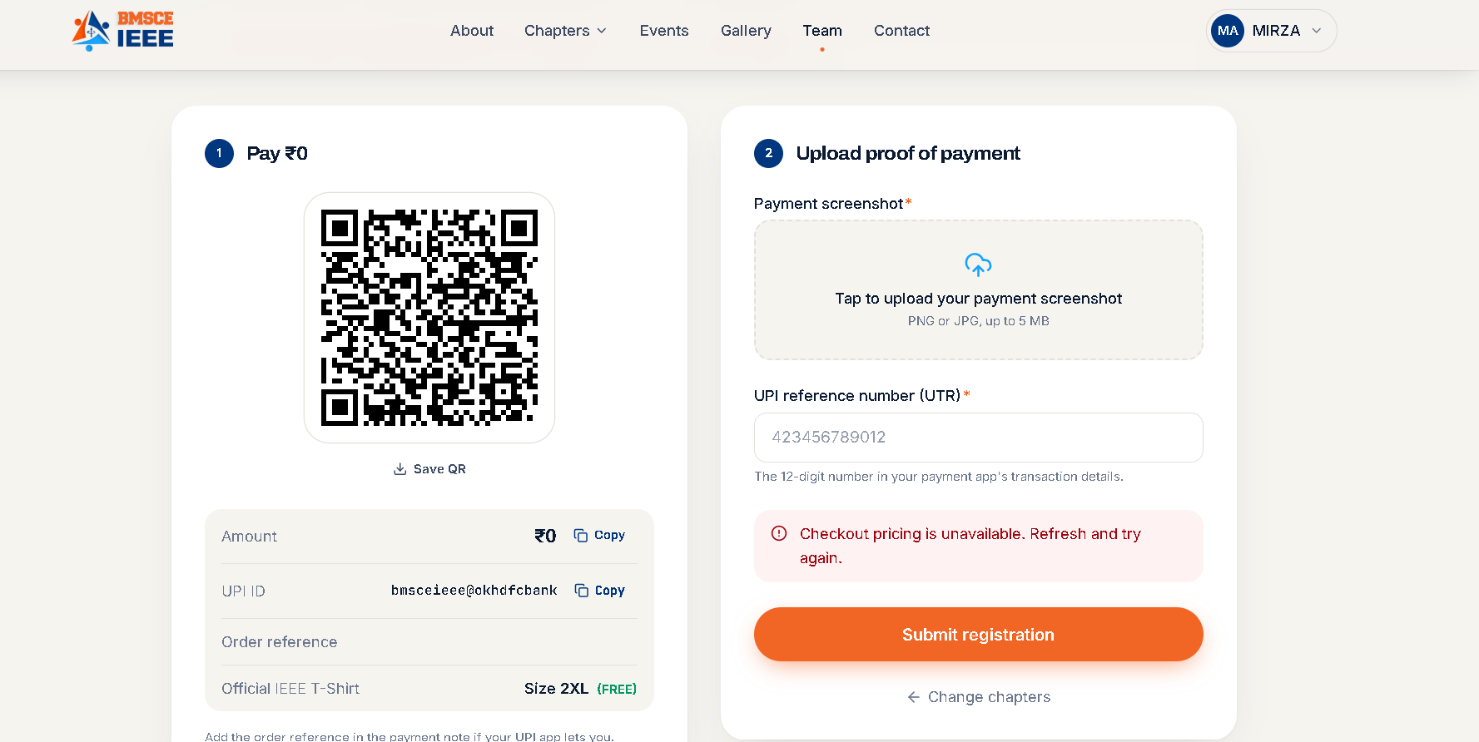
QR is wrong and the amount when we add chapters doesnt reflect here:
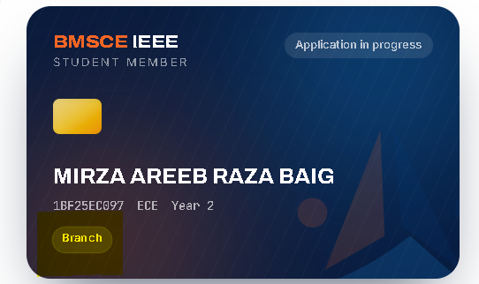
ECE SHOULD COME DOWN with branch or else branch part can be removed

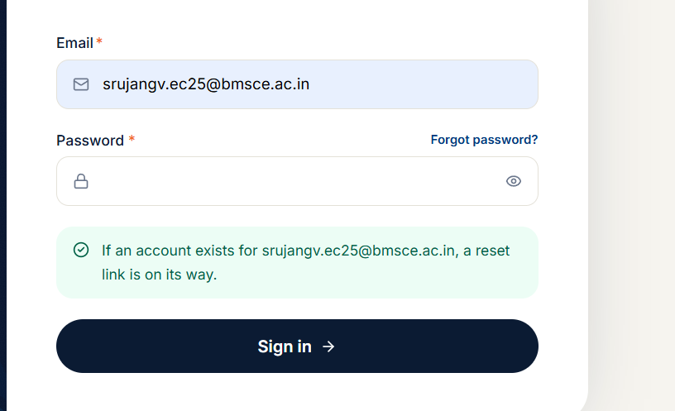
Reset link hasnt been sent even after 4 hours

backend & technicals

- Backend issues in payment and pricing
- 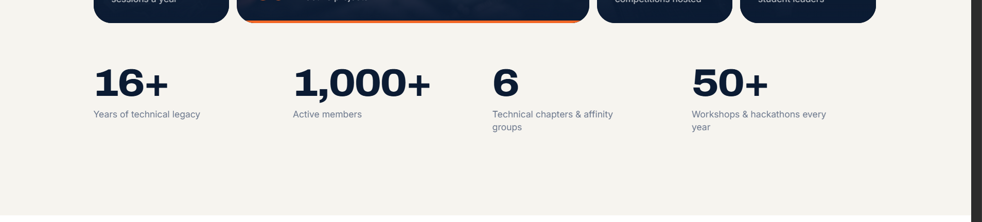
- Repeated twice in the home page is it really required ?

- Not all branches mentioned in sign up page
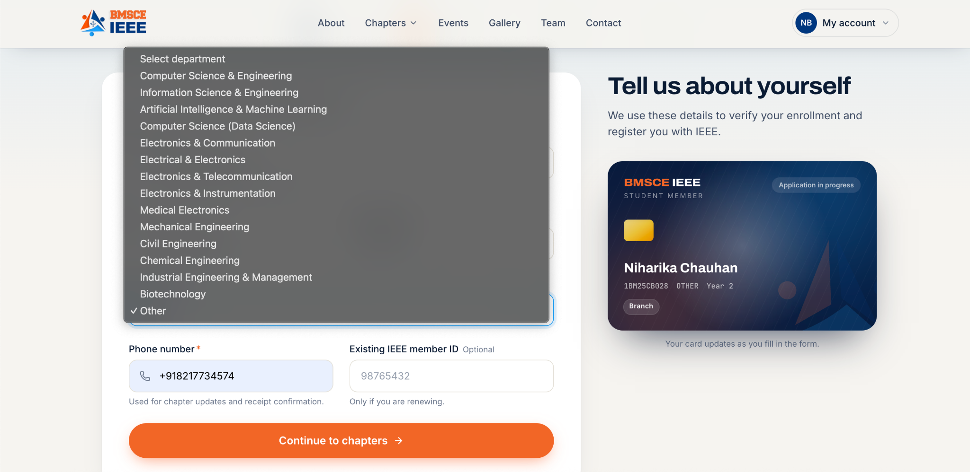
- 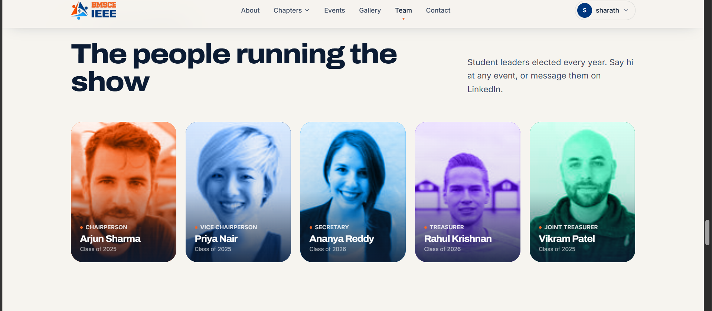

Notes and Feedbacks
The website tends to push alot towards card, make it kind of non-chalant
The Kaziranga House ( check out this website once )

